INSTRUCTION MANUAL
IE ACTIVE

Catalogue
1. IE Web Log IN 3
2. IE Web Page Introduction 4
2.1 Monitoring Channel 4
2.2 Monitoring Window Shift 5
2.3 Shortcut Key Operation 5
2.4 Audio Settings 5
2.5 Other settings 5
2.5.1 Color 5
2.5.2 Reboot 6
2.5.3 Voice Intercom 6
2.6 PTZ Control Panel 7
2.6.1 PTZ Direction 7
2.6.2 PTZ Step Length 7
2.6.3 Video Display Control 8
2.6.4 Preset Point 8
2.6.5 Cruise between points 8
2.7 System Menu 9
2.7.1 Playback 9
2.7.2 Log 13
2.7.3 Device setting. 14
2.7.4 Client-side Configuration 19
2.7.5 Exit 22

1. IE Web Log IN
Open IE browser and input with IP address, log in with user name and password，as pic1：
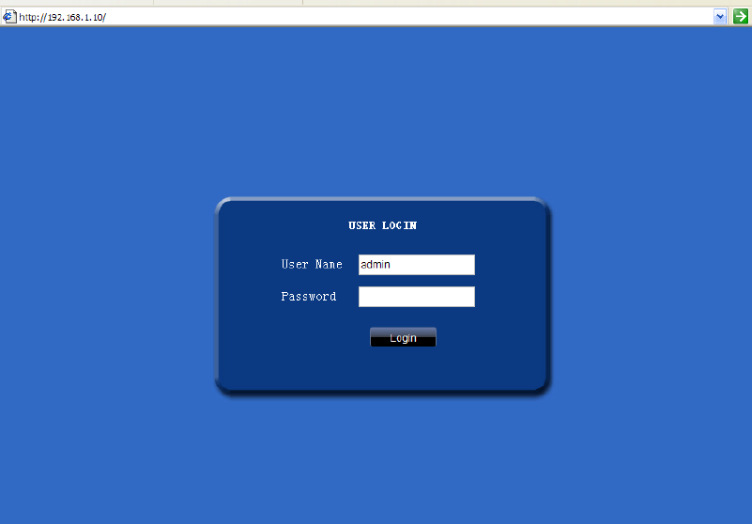
Pic 1 WEB Control Interface
③
After log in，you will enter the interface as pic 2:
②
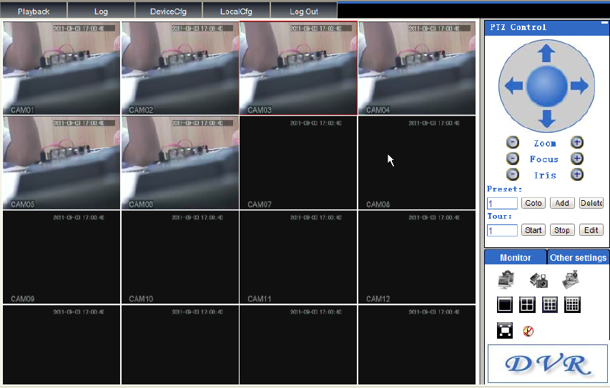
①
Pic 2 WEB Interface after Log In

2. IE Web Page Introduction
①——Monitoring Settings/Other Settings
②—— PTZ Control
③—— System Menu

2.1 Monitoring Channel
First click 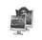” disconnect all channels”,Secord click ,screen get will be as follow
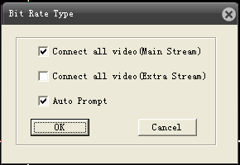
You can select as “Main Stream” or “Extra Stream”,after you press button “OK”,screen got will be as pic 5；
Pic 4 WEB Video Monitor Screen

2.2 Monitoring Window Shift
and 
To shift the monitoring window between full screen & single channel & 4 channels & 9 channels & 16 channels，when you are under full screen status，click “Esc” button of you PC keyboard can exit.

2.3 Shortcut Key Operation
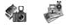
 ——Snapshot，click this key，to snapshot few pictures from video， Picture storage path can be revised at“System Menu”->“Client Side Settings”->"System Settings".
 ——Full channel record，to start full channel video recording at client side；
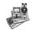 ——Stop full channel record，to stop full channel video recording at client side。

2.4 Audio Settings
——
To open & stop the audio of monitoring video。

2.5 Other settings
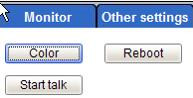

2.5.1 Color

If you press 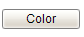,then sceen got will be as follow
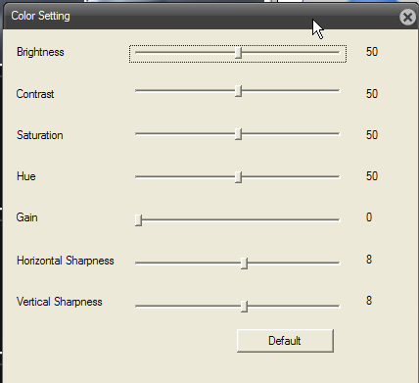
Color setting：
Brightness——Brightness Adjustment，to adjust the brightness of monitoring screen；
Contrast ——Contrast adjustment，to adjust the contrast of monitoring screen；
Saturation——Saturation adjustment，to adjust the saturation of monitoring screen;
Hue/Gain——Hue/Gain adjustment，to adjust the Hue/Gain of monitoring screen;
H/V——Horizontal/Hertical Sharpness adjustment，to adjust the Horizontal/Hertical Sharpness of monitoring screen;
——To restore the Brightness、Contrast、Saturation、Chroma and so on into default value.

2.5.2 Reboot
If you press ——Can reboot the DVR。

2.5.3 Voice Intercom
If you press then see pic ，to start bidirectional talk; click , see pic ，Voice intercom was stopped.

2.6 PTZ Control Panel
Remark：Before operating PTZ Control Panel，user should set PTZ protocol in advance at System Menu->Device Configuration Module->System settings->PTZ settings.
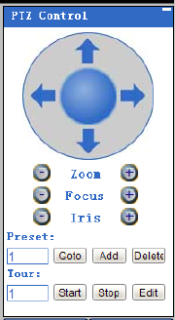
①
②
③
④
Pic 5 PTZ Control Panel diagram
①——PTZ Direction ②—— Video Display Settings
③—— Preset Point ④—— Cruise Between Points

2.6.1 PTZ Direction

PTZ：Support８directions: Up、Down、Left、Right.

2.6.2 PTZ Step Length
Step length：mainly used for setting the rotation rate of PTZ，For example: Rotation rate of step length with 8 is quite larger than the one with step length of 1，Step length range is 1-8,the default Step length is as 1.

2.6.3 Video Display Control

Zoom：Used for the DVR that was connected with dome camera，can enlarge or reduce the override of video；
Focusing：Used for the DVR that was connected with dome camera，can enlarge or reduce the focal length of video.
Diaphragm：Used for the DVR that was connected with dome camera，can increase and reduce the diaphragm of video.

2.6.4 Preset Point
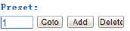
Turn the camera to the specific point through direction keys, then input the preset point value, and click“” to save it，or click“”to delete the preset point，and click“”to use this preset point。

2.6.5 Cruise between points

To input cruise point No.，click edit key，enter Pic 6：
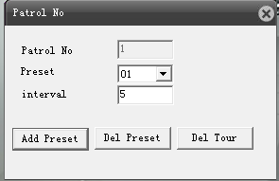
图6 Cruise line editing interface
To select the specified preset point at the drop-down box，input time interval，click，to add this preset point at cruise line，click，is to delete this preset point at cruise line，click，is to delete the set cruise line.

2.7 System Menu
- Playback：Enter the playback mode，can base on the time and record mode to search or
download video accordingly.；
2、Log：Show the log information of web client side；
3、Device-side configuration(DeviceCfg):
To remote setting the configuration of device-side accordingly，the setting will be synchronous to local device，including Recording、Alarm、System Setting、Management Tool、System Information etc.（Remark：Device can be set only when it was connected successfully）；
- Client-side Configuration(LocalCfg):
Alarm settings —— Set alarm on client-side，start remote network client interaction
capabilities；
System Setting —— Set client-side record directory, snapshot directory.
5、Log Out：To close web client-side，return to log in interface.

2.7.1 Playback
Enter the playback mode at system menu from web page，to search related video after setting playback mode, video type、record parameter settings.
Operation in detail：
Step 1、Choose video playback mode，including by file and by time，if choose by file, the video search interface will be as pic7, if choose by time, the video search interface will be as pic 8.
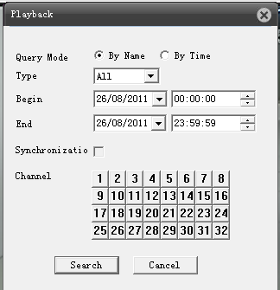
Pic 7 Video search interface by file mode
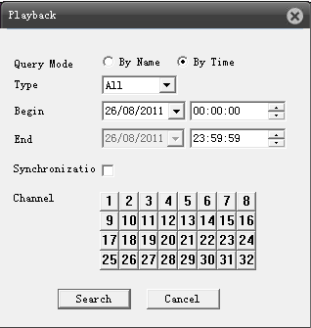
Pic 8 Video search interface by time mode

Step 2、Choose the playback mode，including All、External Alarm、Motion Detect、General record、Manual Recording、All pictures、Alarm Snapshot、Motion Detect Snapshot、Timing Snapshot and Manual Snapshot，set record period with beginning time and end time，under the playback mode of by time, you can choose whether to be synchronous, select the recording channel, then click，to enter the video playback and download interface；
Step 3、Choose the specified video from the file list，click，to playback this video at
the playback window，Playback mode by file as Pic 9, Playback mode by time as Pic
10.

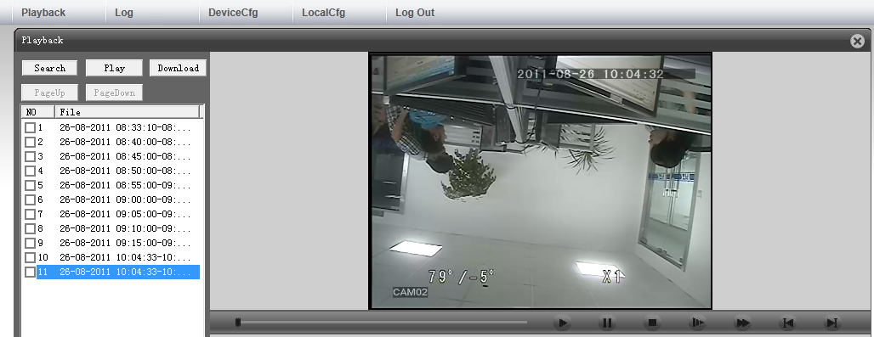
Pic 9 Video playback mode "by file"
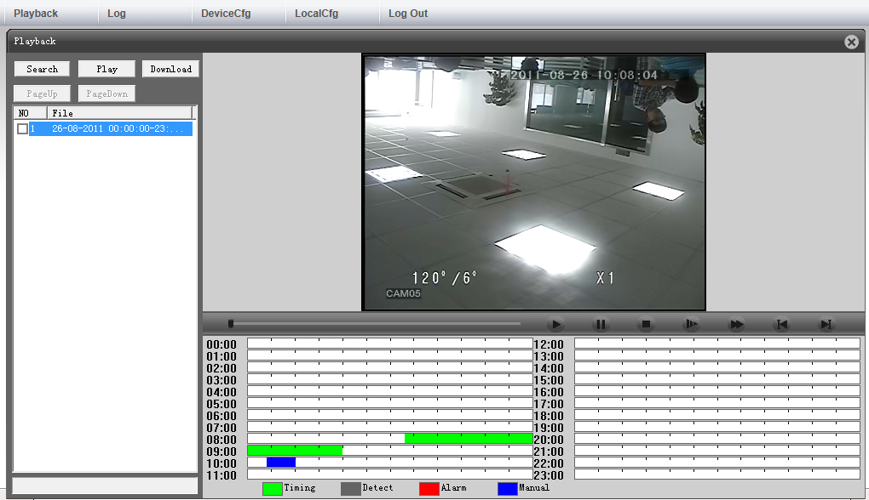
Pic 10 Video playback mode "by time"

Remark：
- When video is playing back, u can use the keys on the progress bar for below operations: such
as play、pause、stop、slow play、 fast play 、previous frame、next frame，and u can see the title and time of channel on the playback window.；
- If the playback mode is by time, there will be a window under the playback screen, shows the
video type of each period, it was demonstrated with colors, each color stands for a type of video, double click the period with color, the video will shift to the specified period to playback.
Step 4、Choose the video that you want to download from the list, click，under the
playback mode of by file，will come out the file save window，set video name and storage
path，click “Save”，system will begin to download the video to PC，see pic 11；If under
the playback mode of by time ，will come out file save window, set video storage path，
then click “Yes”，system will begin to download video to PC, see pic12.
Step 5、When it finished download，will come out “download finished”，click ，to
finish the whole download.

Remark：Both playback mode can support video download while it is playing back, click
at the playing back interface，can return to related video search interface.
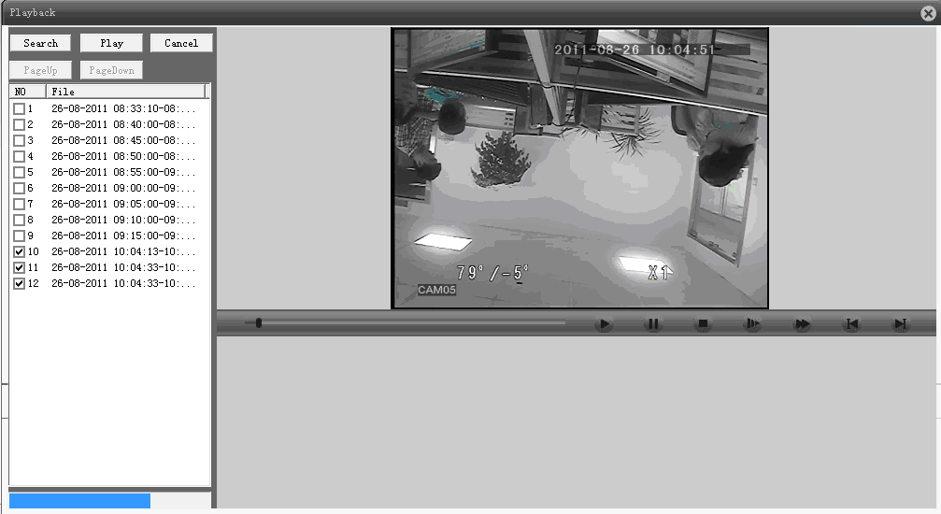
Pic 11 Download and playback under mode of by file
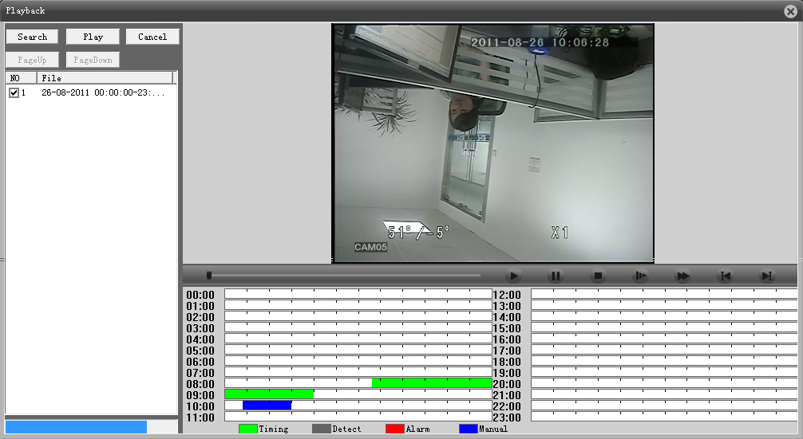
Pic 12 Download and play back under mode of by time

2.7.2 Log
To open the Log mode at system menu of web page，there will be log information window，including alarm log and operation log.
Alarm Log—— Need to set alarm and client-side,，by triggering the device-side to alarm，enable remote web client-side linkage function, then there will be log information comes out.
Operating Log —— to show the operating log information of web client-side.
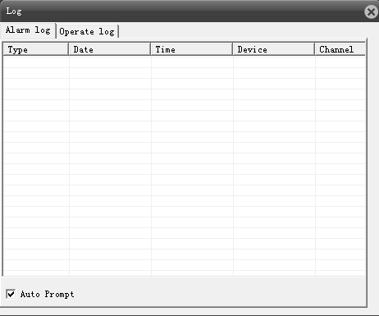
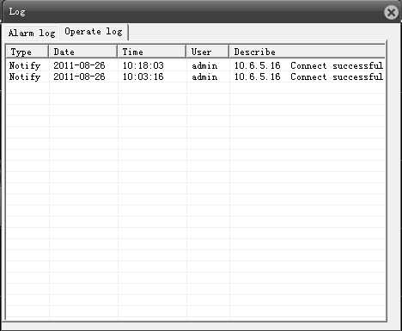
Pic 13 Alarm log and operation log interface

2.7.3 Device setting.
To open the device configuration from system menu of WEB page，come out device setting window，including 5 parts: Record、Alarm、System Settings、Management Tools、System Information，you can set device on these interface，the settings will be synchronous to local device. (Remark: Device can be set until it is connected successfully)

2.7.3.1 Record
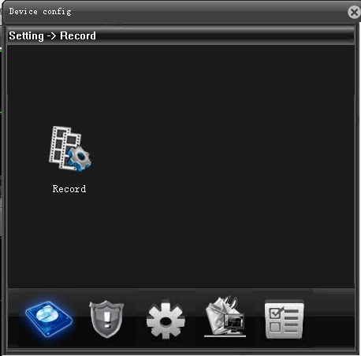
Pic 14 Video Recording Window
Video record including record settings and picture storage, you can set the record status of device at record settings interface, set snapshot period and type at picture storage interface.

2.7.3.2 Alarm Settings
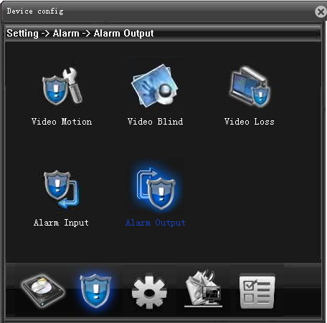
Pic 15 Alarm Setting Window
Alarm function including motion detect, video blind, video lost, alarm input & alarm output. You can set motion detect alarm data at motion detect interface,，set video blind alarm at video blind interface,，set video lost alarm at video lost interface, set external alarm at alarm input interface, search alarm output and alarm output interface.

2.7.3.3 System Settings
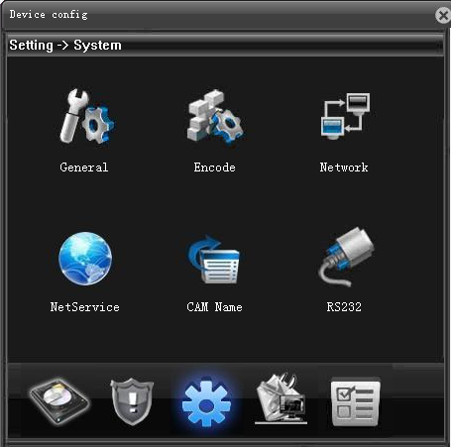
Pic 16 System Setting Window
System settings include General Settings, Encode, Network, and Net service, Channel Title, PTZ and Serial Ports Settings. You can set time, video system etc at general setting interface, set encode capability and encode interface，set web site, video protocol at network interface, set net service parameter at net service interface, revise channel title and channel title interface, set PTZ control parameter at PTZ interface, set serial ports and PTZ function, baud rate, address etc at serial ports settings.

2.7.3.4 Management Tools
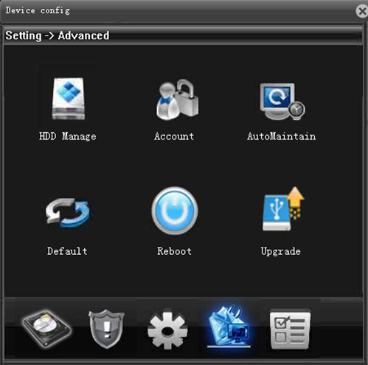
Pic 17 Management Tool Window
Management Tool including HDD manage, Account, Auto Maintain, Restore, Reboot and Upgrade. You can clear the data on HDD at HDD manage interface, can manage the account and account interface, can auto-reboot device and delete old data in auto maintain interface, can restore to default at restore interface, can reboot device at reboot interface, can upgrade system with flash stick at upgrade interface.

2.7.3.5 System Information
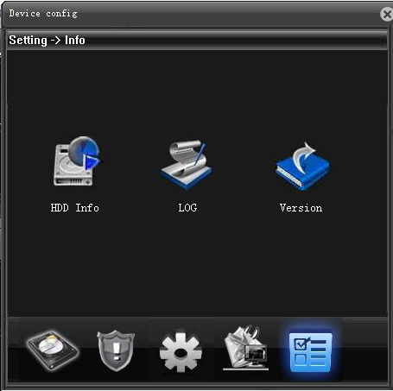
Pic 18 System Information Window
System information includes HDD Information, Log Information, and Version Information. You can review record time, HDD type and capacity at HDD Information interface, can review system log information at Log Information interface, can review system version information at version information interface.

2.7.4 Client-side Configuration
To open the client-side configuration at system menu from web page, including Alarm Settings, System Settings, and About.

2.7.4.1 Alarm Settings
Alarm Settings —— to set device-side with alarm, enable the remote web client-side linkage function, including general settings and alarm settings. General setting is to choose alarm type, whether enables, click "apply" to save, as pic 19; alarm setting is to add or delete video channel, as pic 20.
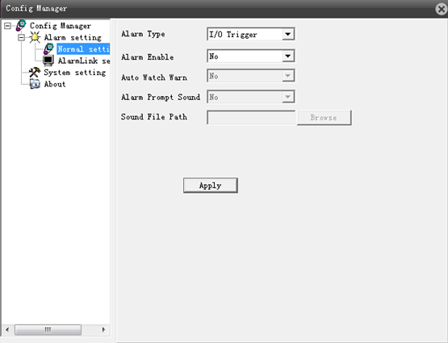
Pic 19 Alarm general settings interface
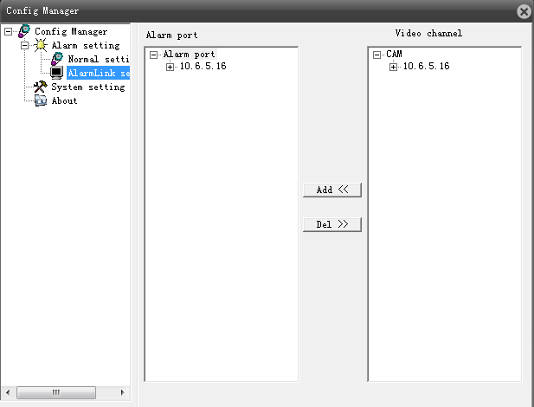
Pic 20 Alarm settings interface

2.7.4.2 System Settings
System Setting—— review and revise the catalogue of client-side video and snapshot, choose whether to enable the function of auto connect to previous monitoring channel, whether choose AVI as the format for local video storage, see pic21.
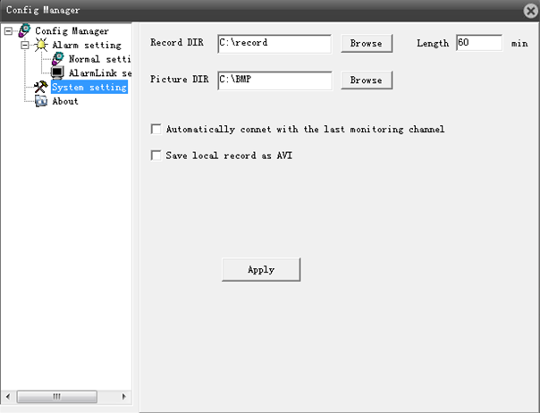
Pic 21 System Settings Window

2.7.4.3 About
You can get information of web version, network module version, player module version, playback module version, video module version and configuration module version at page 22.

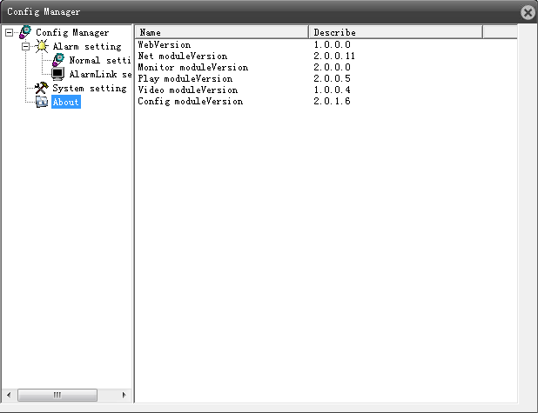
Pic 22 Web module version information interface

2.7.5 Exit
Click "Exit" at system menu from web page, can close web client-side and return to the log in interface.

