E-TOUCH ICLOUD SETUP

E-touch / iCloud for Moblie phone software: vMEyeCloud / Android, vMEyeCloud / iphone

1、Pls turn on the DVR
2、Make sure that DVR have already connected the Internet
3、Pls link to http://xmeye.net on your PC，that should be as below：
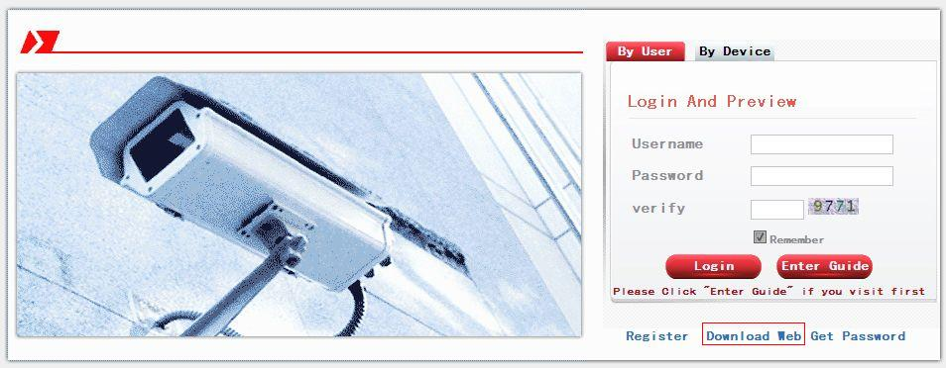
- Pls Download Web Active and run the Active

- Install the Active as below:
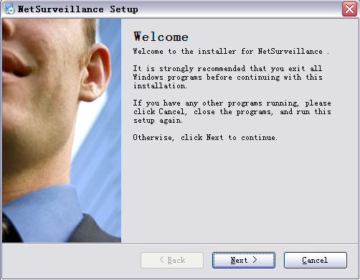

- Press "Next", and get into the next step as below：
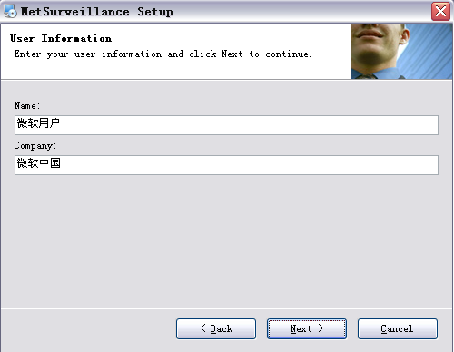
- Press “Next” as below：
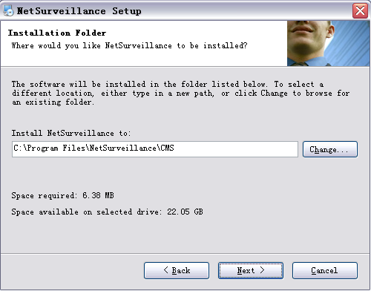

- Choose the storage directory，press “Next” as below：
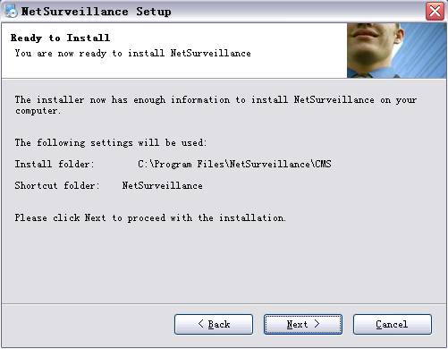

- Press “Next” and finish install as below：
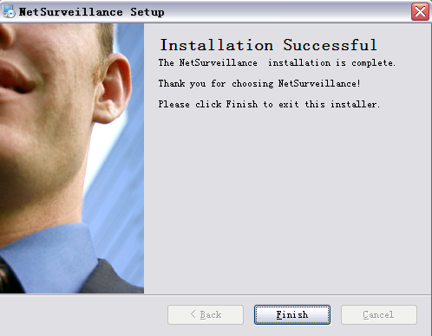

.

5、After finish install, pls get back to：http://xmeye.net。
1）Register

a. press Register as below：
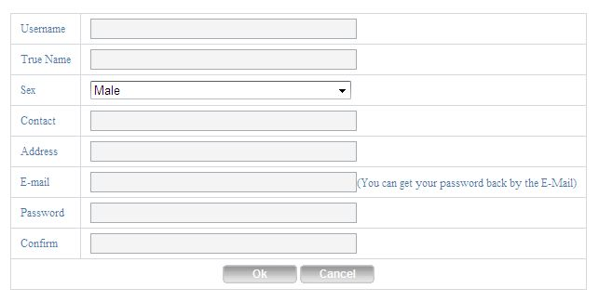

b. Pls log in as below：
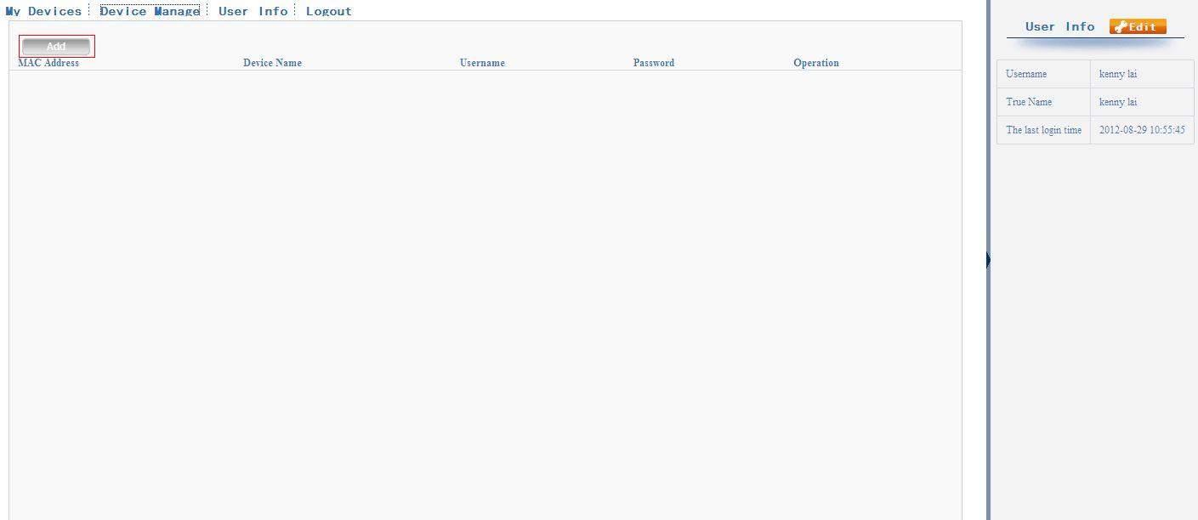

c. Device Manage and add as below：
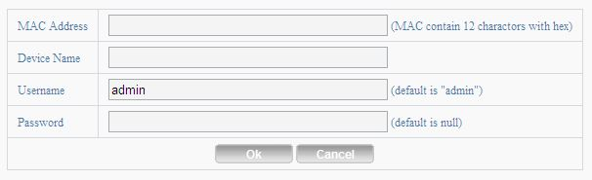
Must be same with DVR
Must be same with DVR
Must be same with DVR

Pls check the Serial number as below：DVR’s main menu ——INFO——VERSION-----Serial NO
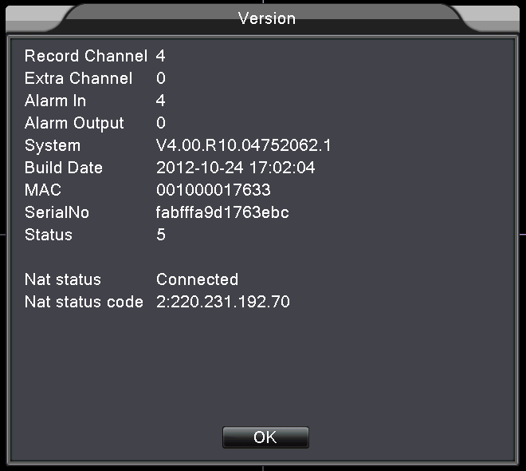

d. After setting，press “My Devices” as below：

