How to use RTSP data
Please confirm you device software version has:R09
- Install vlc player
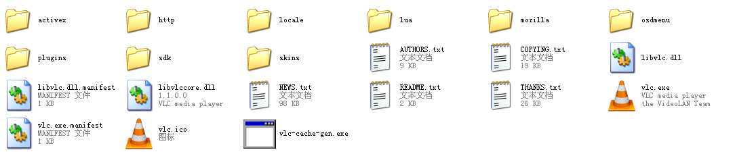2.connect setup
Open VLC.EXE
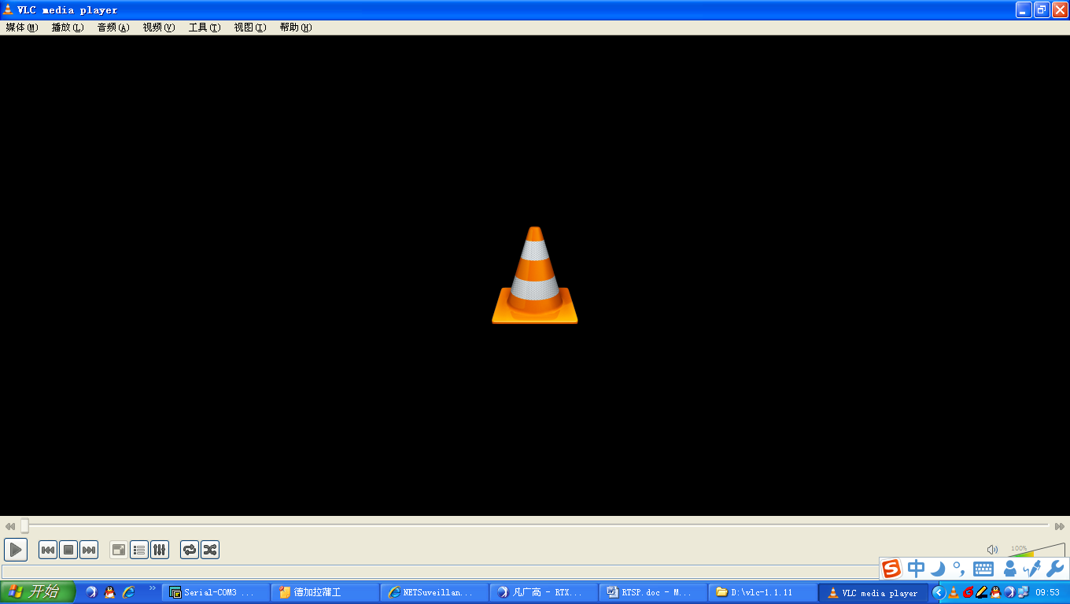open network streaming
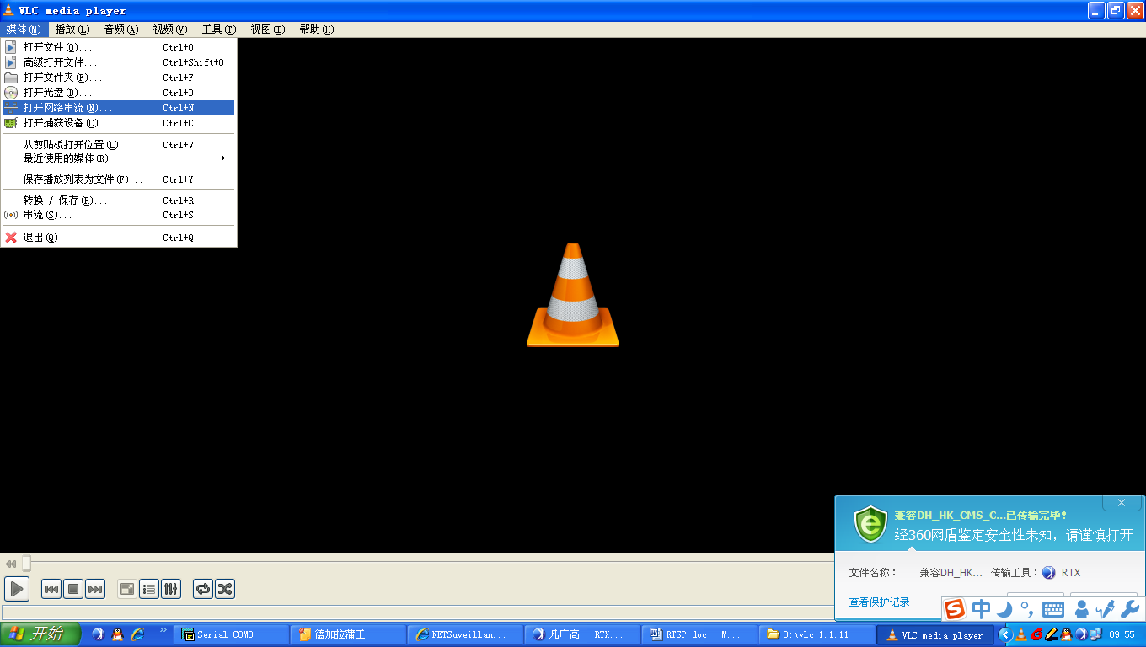

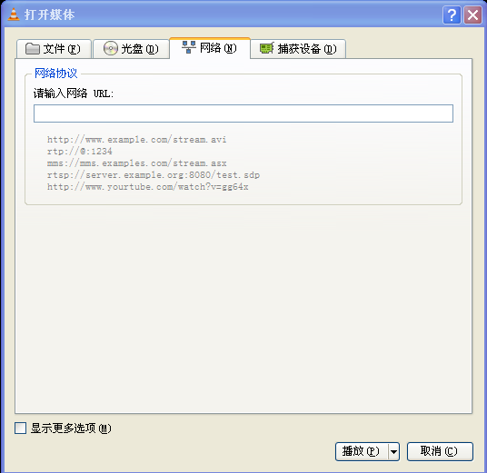
Input follow address a: please input URL
rtsp://10.6.3.57:554/user=admin&password=&channel=1&stream=0.sdp?
10.6.3.57 is the IP of the device you will access to
:554 is the port of RTSP service, and it can be changed in the device/network
user=admin is the user of which you login the device
password= no password
channel=1 first channel
stream=0.sdp？main streaming

